Wealth Strategies Group
an office of MetLife Financial Services

225 W. Santa Clara Street, Suite 1450

San Jose, CA 95113
(408) 454-2555

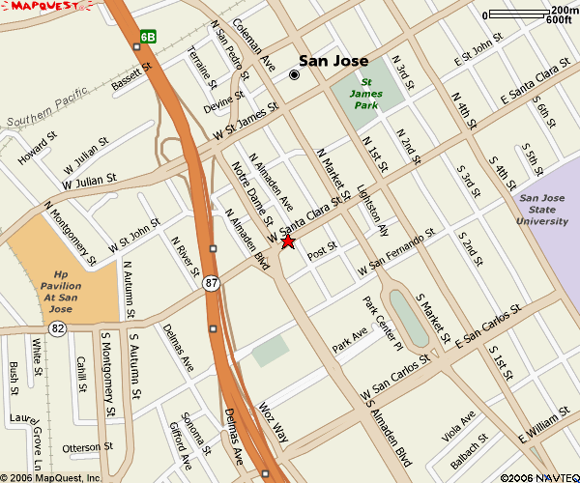

Directions from OAKLAND
Take I-880 S towards SAN JOSE
Merge onto US-101 S via EXIT 4B toward
LOS ANGELES
Merge onto I-280 N toward SAN FRANCISCO / DOWNTOWN SAN JOSE
Take the GUADALUPE PARKWAY / CA-87 N exit
Take the SANTA CLARA STREET exit toward DOWNTOWN SAN JOSE
Turn RIGHT onto W SANTA CLARA ST
Turn LEFT onto N. ALMADEN AVE
Turn LEFT into PARKING GARAGE,
Park in VISITOR PARKING

Directions from PLEASANTON
Take I-680 S toward SAN JOSE
Keep LEFT to take I-280 N toward DOWNTOWN
SAN JOSE
Take the GUADALUPE PARKWAY / CA-87 N exit
Take the SANTA CLARA STREET exit toward DOWNTOWN SAN JOSE
Turn RIGHT onto W SANTA CLARA ST
Turn LEFT onto N. ALMADEN AVE
Turn LEFT into PARKING GARAGE,
Park in VISITOR PARKING

Directions from SOUTH SAN JOSE
Take US-101 N toward SAN JOSE
Merge onto CA-85 N via EXIT 377A toward CUPERTINO / MTN VIEW
Merge onto CA-87 N toward DOWNTOWN SAN JOSE
Take the SANTA CLARA ST exit toward JULIAN ST
Take the SANTA CLARA STREET exit toward DOWNTOWN SAN JOSE
Turn RIGHT onto W SANTA CLARA ST
Turn LEFT onto N. ALMADEN AVE
Turn LEFT into PARKING GARAGE,
Park in VISITOR PARKING

Directions from the PENINSULA via US-101
Take US-101 S toward SAN JOSE
Merge onto CA-87 S / GUADALUPE PKWY
Take the JULIAN ST exit- EXIT 6B- toward
ST JAMES ST
Stay STRAIGHT to go onto N ALMADEN BLVD
Turn LEFT into PARKING GARAGE,
Park in VISITOR PARKING

Directions from the PENINSULA via I-280
Take I-280 S toward SAN JOSE
Take the GUADALUPE PARKWAY / CA-87 N exit
Take the SANTA CLARA STREET exit toward DOWNTOWN SAN JOSE
Turn RIGHT onto W SANTA CLARA ST
Turn LEFT onto N. ALMADEN AVE
Turn LEFT into PARKING GARAGE,
Park in VISITOR PARKING

